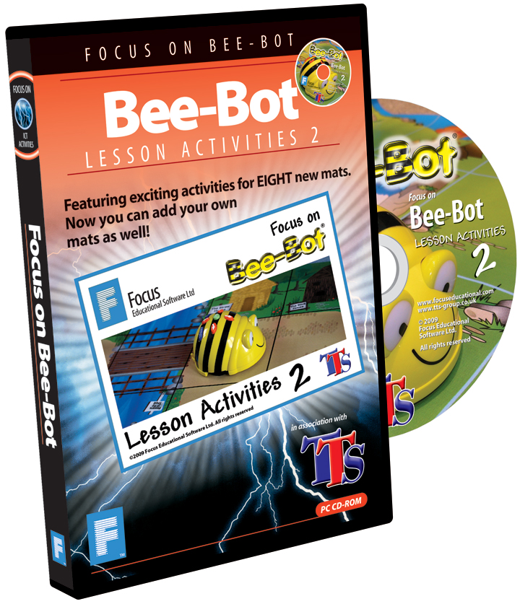
Software to help you make the most of the
Bee-Bot experience…..
Focus Educational Software Ltd is the publisher of three easy-to-use interactive programs supporting the use of Bee-Bot hardware in schools.

Focus on Bee-Bot: Lesson Activities 1 is the first program in the series and won the BETT Award for Best Digital Content, Primary Core Subjects.
The program allows users to create a 3D world for Bee-Bot on-screen and includes sequencing activities with feedback for 8 real life Bee-Bot mats:
* Alphabet * Money * Race Track * Shapes and Colours * Busy Street
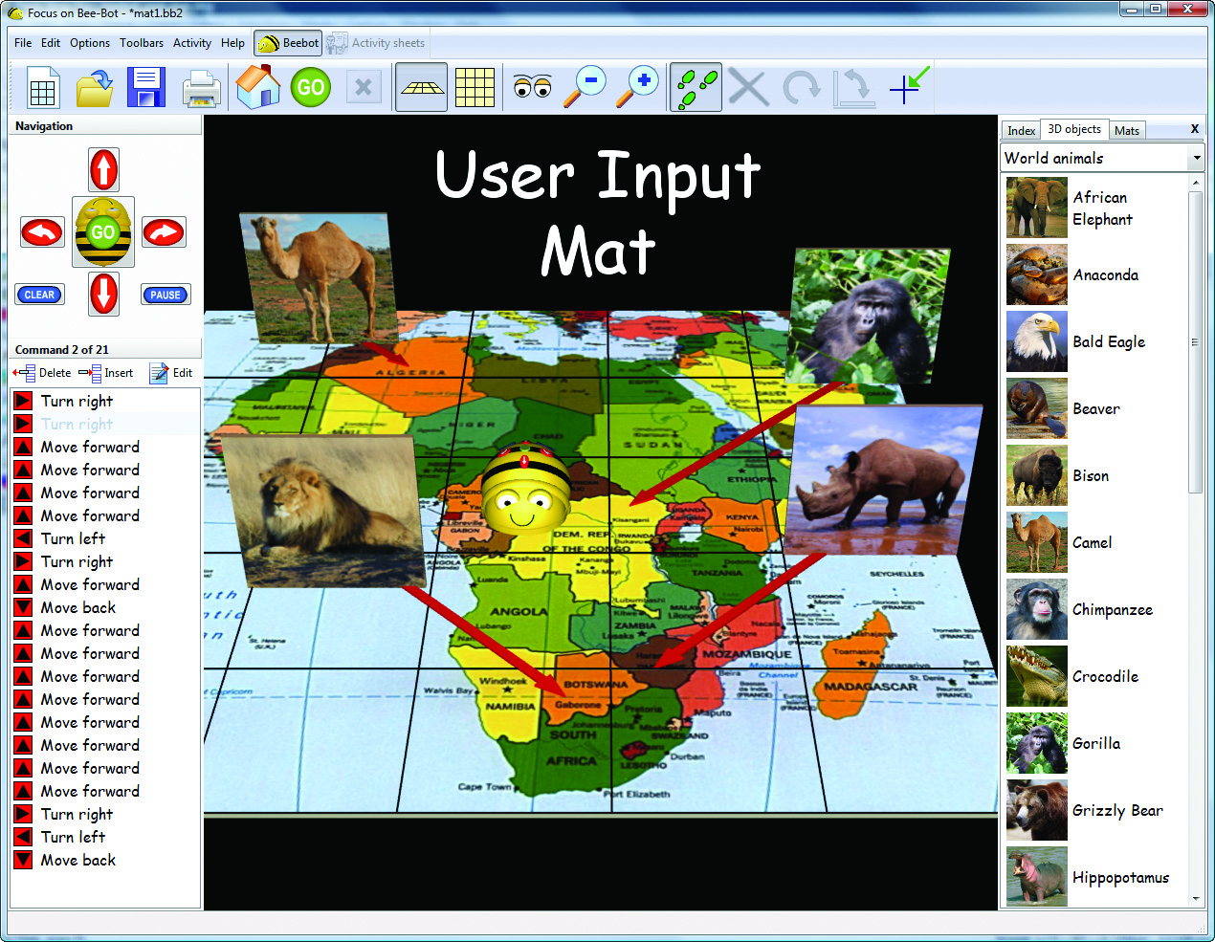
* Treasure Island * Number Track * CVC

Find out what BECTA had to say about the program: http://www.youtube.com/watch?v=8UTv9hzyV-k

Focus on Bee-Bot: Lesson Activities 1 was reviewed by Simon Haughton in ICTOPUS Sharing Good Practice 40: http://www.ictopus.org.uk/downloads/sgp/SGP40.pdf

Focus on Bee-Bot: Lesson Activities 2 was developed in response to questions from users asking if was possible to input images and create user designed on-screen activities. The map of Africa activity mat on the right was created in the program by importing and saving an image direct from Google Images. Users can simply select an image, choose the number of mat squares and the program does the rest.

User input activity mats can be created from any digital photograph of a reasonable size. There are many mosaic images available on sites such as http://www.flickr.com. These are ideal as they are already arranged in square patterns. Visit the site and search for ‘animal mosaic’ or ‘plant mosaic’ to see what’s available.

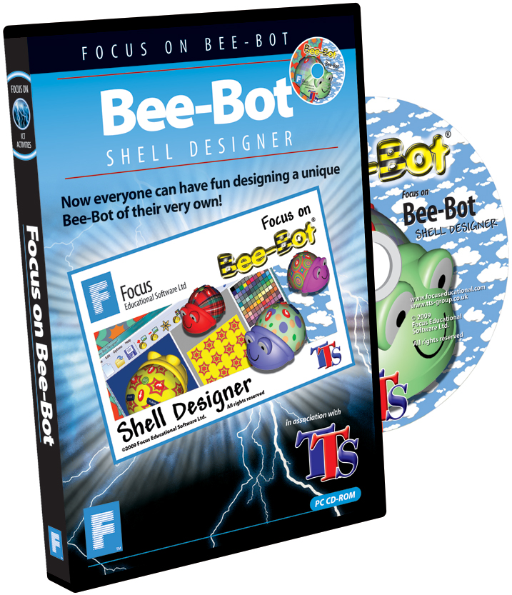
Focus on Bee-Bot: Lesson Activities 2 also features activities for 8 popular Bee-Bot activity mats in addition to the ones in the Bee-Bot Lesson Activities 1 program:
* Farmyard * Seaside * Fairy Tale * Katie Morag
* Community * World Map * UK Map * Bee-Bot’s Home

Bee-Bot Shell Designer seamlessly integrates with both the Bee-Bot Lesson Activity programs and encourages children to learn about image editing by designing unique on-screen Bee-Bot shells of their very own. Once saved to hard disk, personalised Bee-Bot shells will automatically display in the Bee-Bot Lesson Activities programs. Program features include the ability to:
* Change Bee-Bots colours
* Create patterns
* Personalise Bee-Bot by adding photos
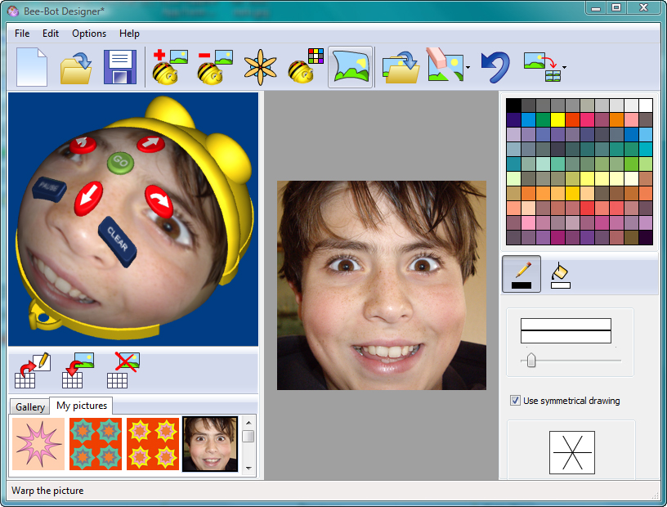
* Introduce Photoshop style image effects into lessons
* Experiment with symmetrical drawing techniques
* Create mosaics and tiled patterns
NB: To operate fully, this program requires Focus on Bee-Bot Lesson Activities 1 or 2 to be installed.

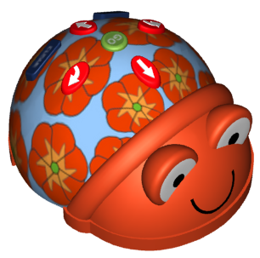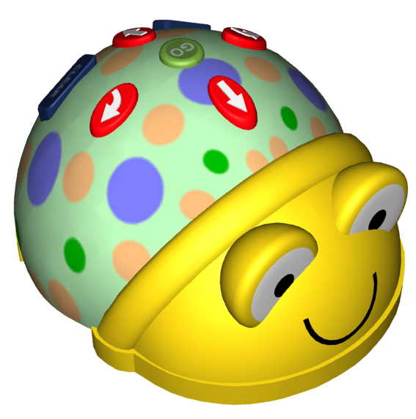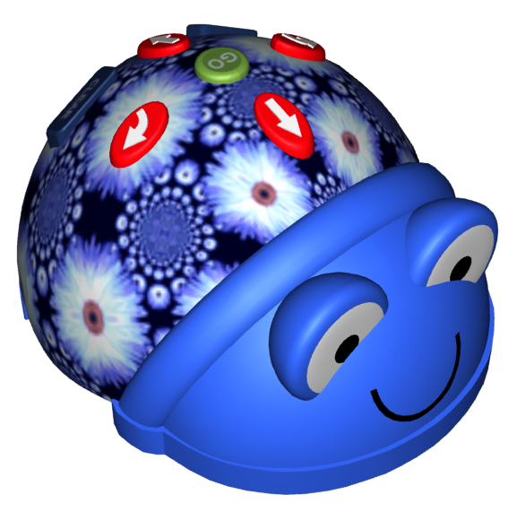
Site licences for each program cost £89.95. Find out more by visiting: www.focuseducational.com

